2CS 419 Compiler
Project Form

Project Idea: Project #1
Description:
A program in Project #1 consists of a sequence of function definitions -.
Each function consists in turn of variable declarations, type declarations,
function declarations, and statements. The types in Project #1 are very
restricted look at table 1.in addition to table 1, single dimensional arrays and
pointer types are possibly using user defined struct types as in C Language.
The array index value can only be simple unary expression such as an
identifier, a constant or another simple array access expression. Project# 1
Language is case sensitive
……………………………………………………………….
Team Members NO#: 7
ID | Name | Level&  Department | Section(Day-from-to) | Role  (Lead/Member) | Grade
201900836 | معاذ احمد نجيب | Level3 &CS | Wednesday  2-4 | leader
201900577 | كريم احمد متولي محمد | Level3 &CS | Wednesday  4-6 | Member
201900566 | فاطمة محمود فؤاد محمود | Level3 &CS | Wednesday  4-6 | Member
201900772 | محمود طه احمد علي | Level3 &CS | Wednesday  4-6 | Member
201900935 | هدير سامح داود محمد | Level3 &CS | Wednesday  2-4 | Member
201900919 | نيفين حمدي سعد احمد | Level3 &CS |  | Member
201900162 | الاء محمدى عبدالعظيم السيد | Level3 &CS |  | Member
Regular Expression, Finite automata and Conversion from RegX to
NFA, NFA to DFA

Regular Expression :
Letter | ( [A-Z] | [a-z] )
Digit | [ 0-9 ]
Digits | Digit +
Sign | + | -
Condition | If—Else
Integer | Iow
SInteger | SIow
Character | Chlo
String | Chain
Float | Iowf
SFloat | SIowf
Void | Worthless
Loop | (Loop | Iterate) when
Return | Turnback
Break | Stop
Struct | Loli
Arithmetic  Operation | (+| -| *| /)
Logic  Operators | (&& | || | ~)
relational  operators | (== | < | > | != | <= | >=)
Assignment  operator | =
Access  Operator | ->
Braces | ({ | } | [ | ])
Constant | Digits
Quotation  Mark | ,
Inclusion | Include
NFA:
- Identifier :- Letter (letter | digit )
letter
ϵ
5
4
ϵ
ϵ
ϵ
ϵ
letter
Identifier
ϵ
9
8
3
2
1
0

digit
ϵ
7
6

- )If | Else) :- Condition
I
f
3
22
4
ϵ
ϵ

ϵ
ϵ
Condition
10
11
ϵ
ϵ
1
0

8
9
7
e
s
l
E
6
5

- Integer :- Iow
w
o
I
Integer
3
2
1
0

- SInteger : SIow

I
w
o
S
SInteger
4
3
2
1
0

- Character : - Chlo
I
o
h
c
Character
4
3
2
1
0

- String :- Chain
n
i
a
h
c
String
5
4
3
2
1
0

- Float :- Iowf
f
I
o
w
Float
4
3
2
1
0

- Sfloat :- SIowf
s
f
w
o
I
Sfloat
5
4
3
2
1
0

- Void :- worthless

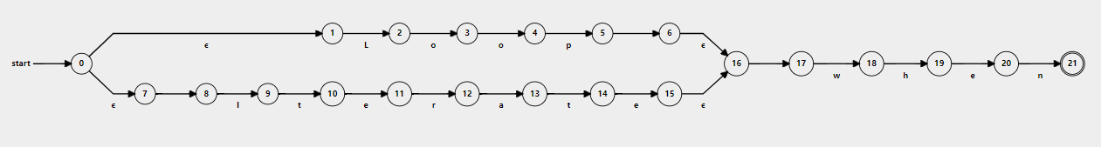
10- Loop :- (Loop | Iterate) when

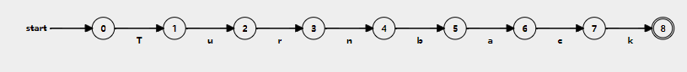
11- Return :- Turnback

12- Break :- Stop
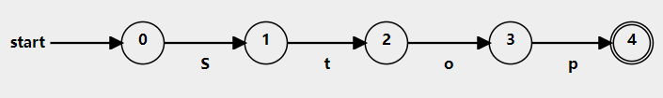
13- Struct :- Loli
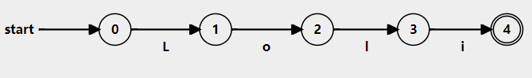
14- Arithmetic Operation :- (+| -| *| /)
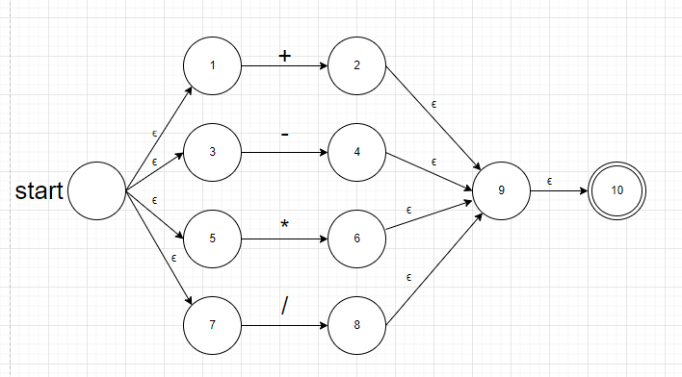
15- Logic Operators :- (&& | || | ~)
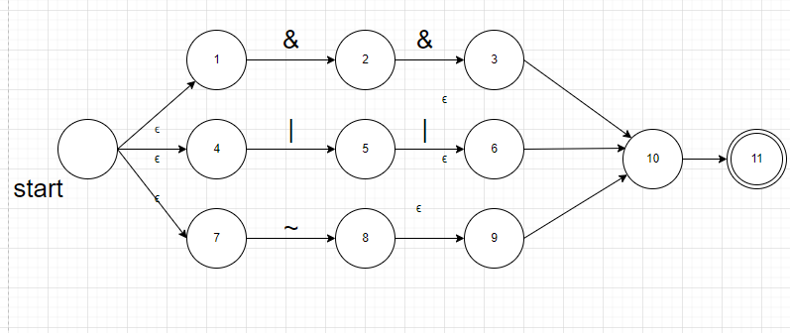
16- relational operators :- (== | < | > | != | <= | >=)
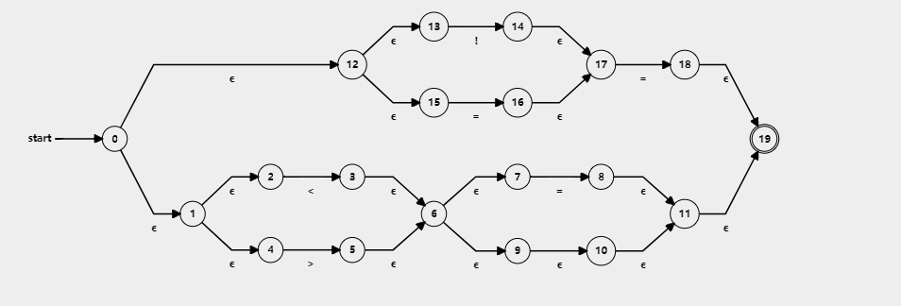
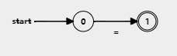
17- Assignment operator :- =

18- Access Operator :- ->
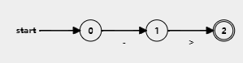

19- Braces :- ({ | } | [ | ])
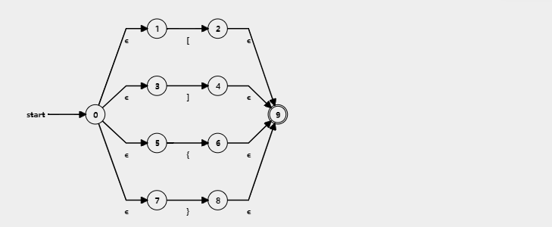

20-Constant :- Digit+
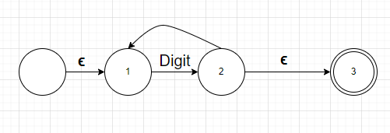
21- Quotation Mark :- ,
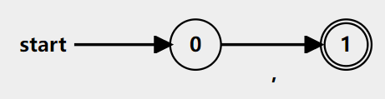
22- Inclusion :- Include
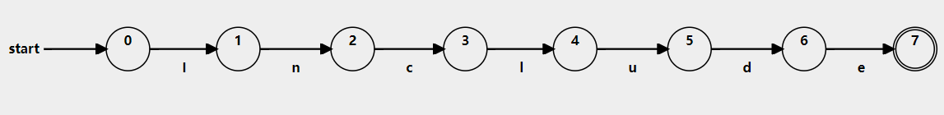

DFA:-
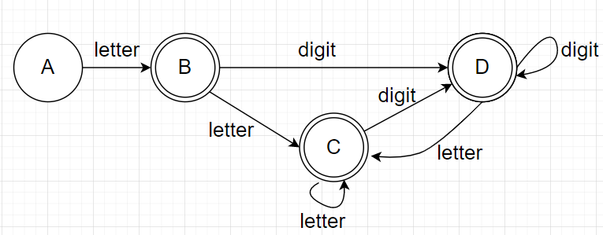
- Identifier :- Letter (letter | digit )

Minimum DFA
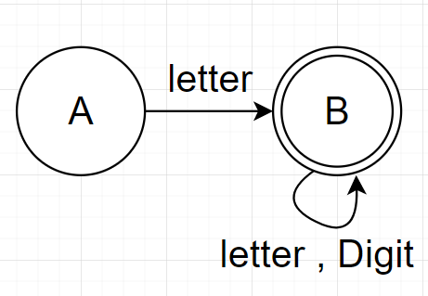
- (If | Else) :- Condition
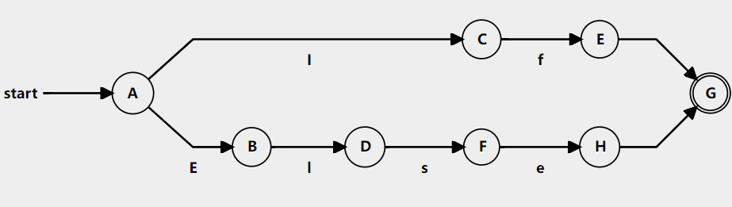
3-Integer :- Iow
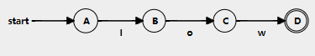

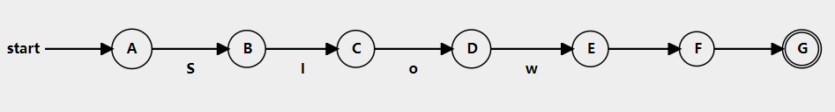
4- SInteger : SIow

- Character : - Chlo
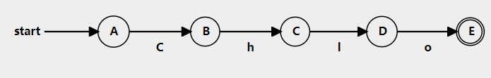
- String :- Chain
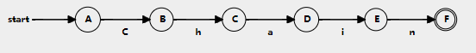
- Float :-
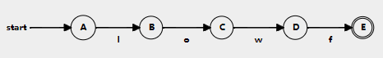

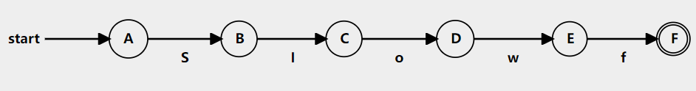
- Sfloat :- SIowf

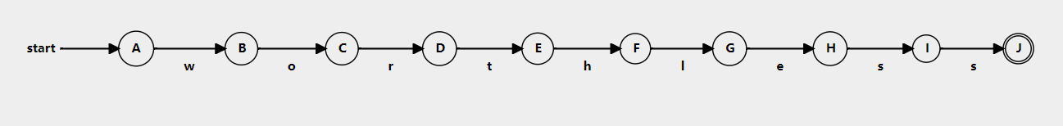
- Void :- worthless
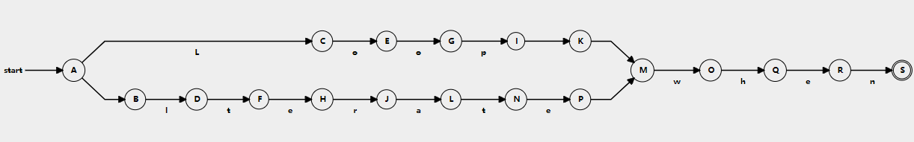
10- Loop :- (Loop | Iterate) when

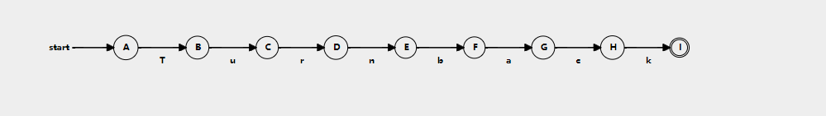
11- Return :- Turnback

12- Break :- Stop
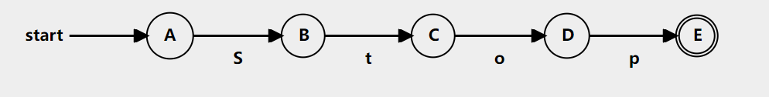
13- Struct :- Loli
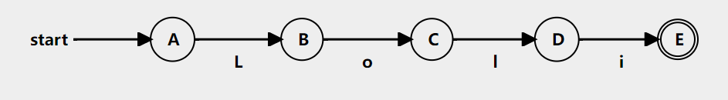
14- Arithmetic Operation :- (+| -| *| /)
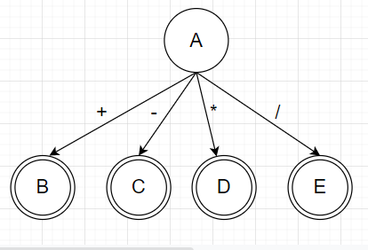

15- Logic Operators :- (&& | || | ~)
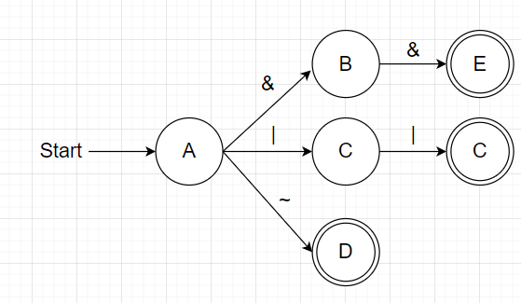
16- relational operators :- (== | < | > | != | <= | >=)
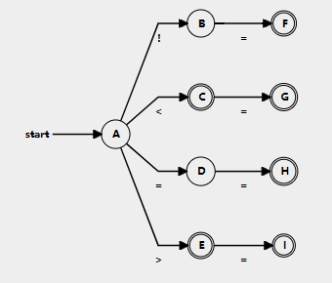
17- Assignment operator :- =
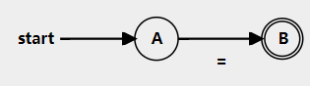

18- Access Operator :- ->
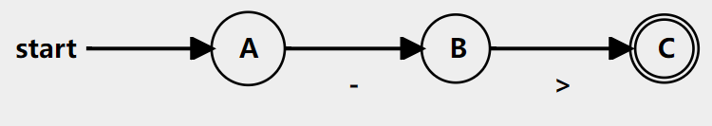
19- Braces :- ({ | } | [ | ])
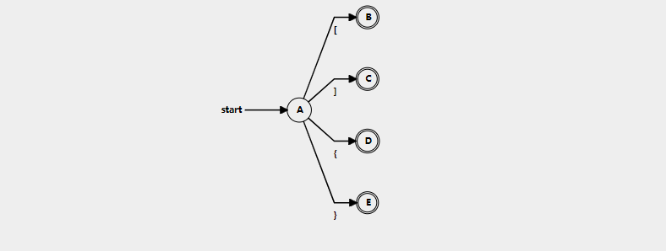
20-Constant :- Digit+
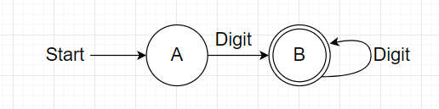
21- Quotation Mark :- ,
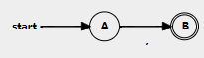
22- Inclusion :- Include
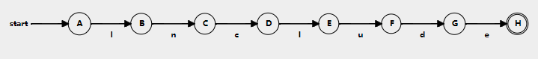
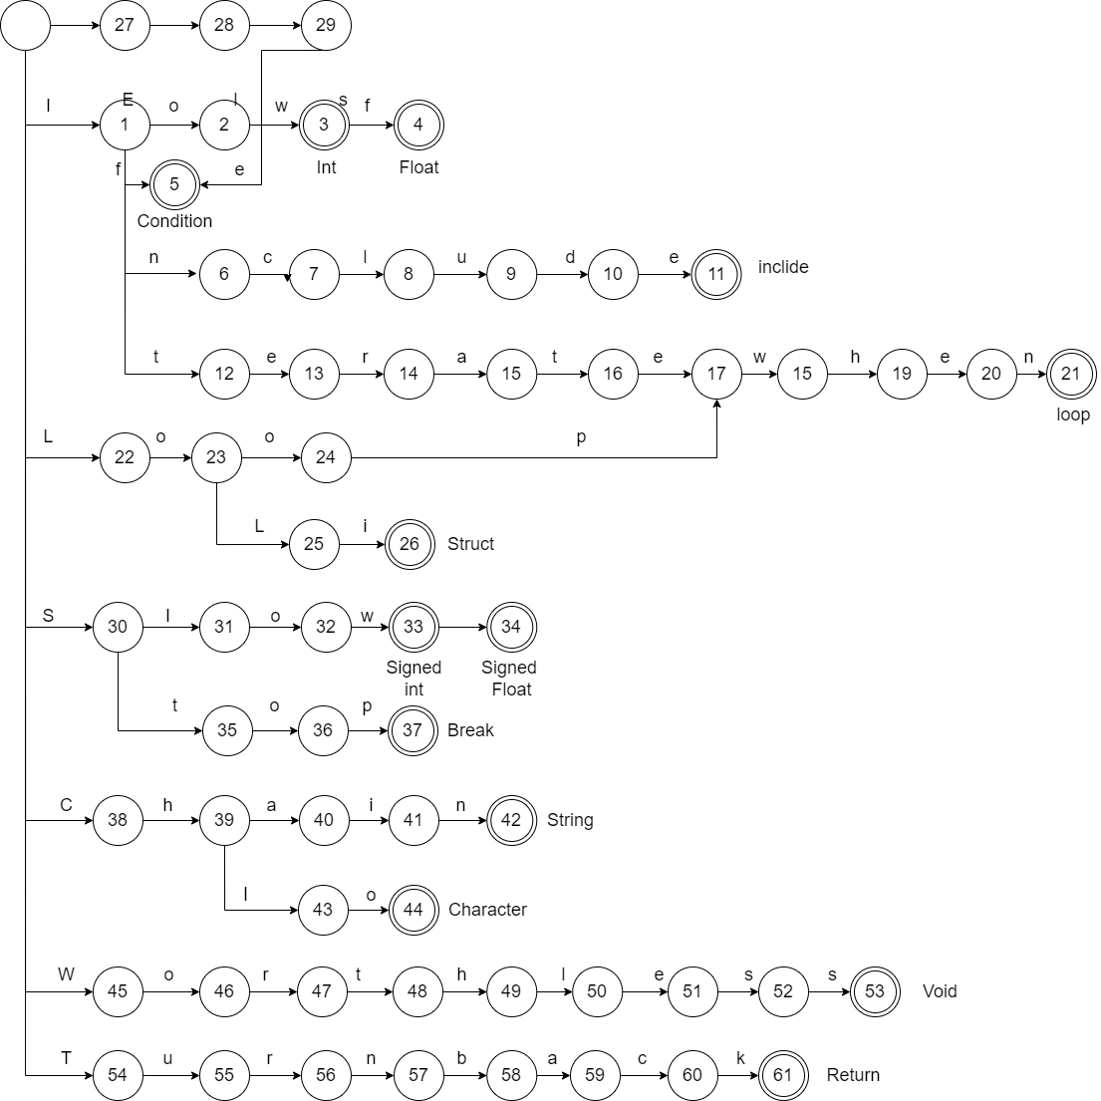
Keywords :-

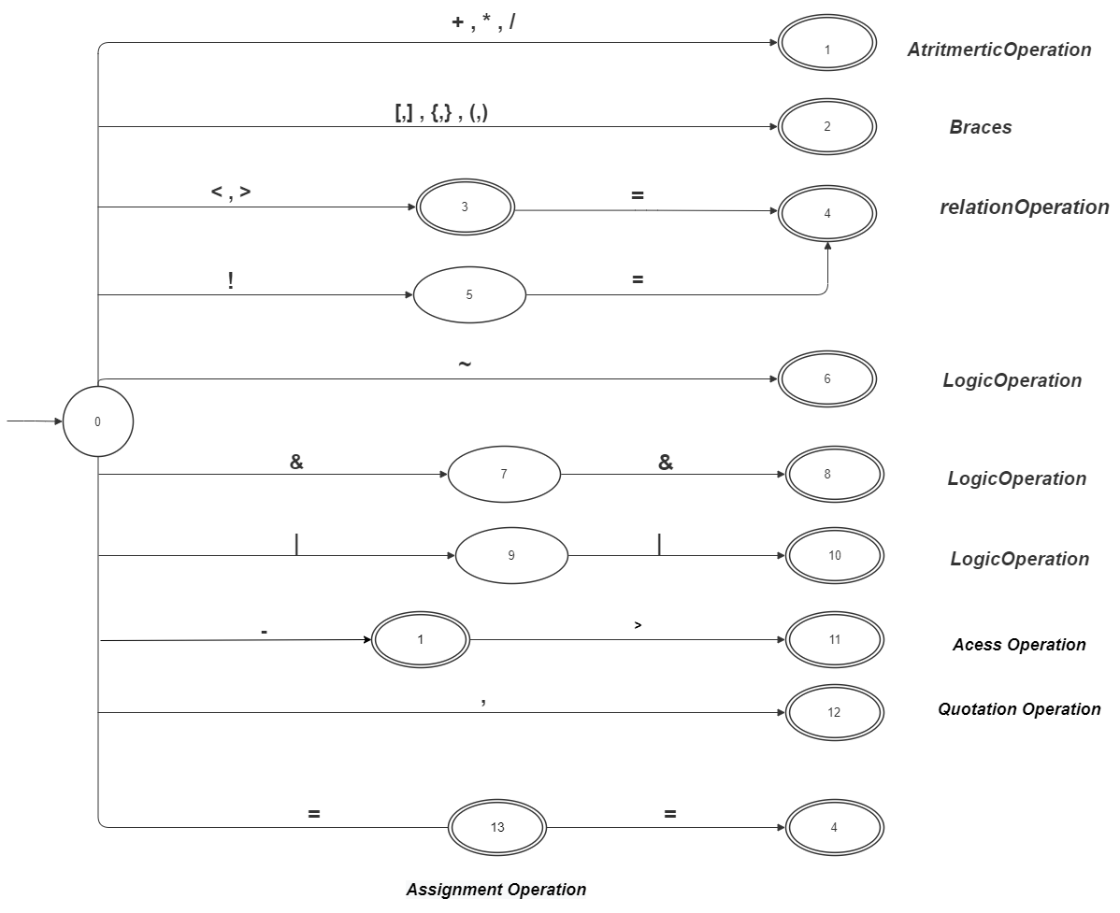

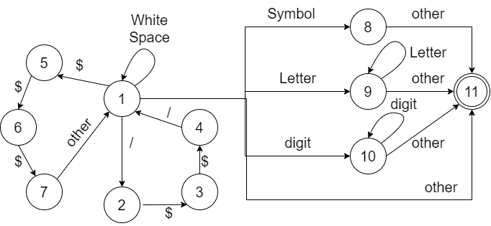
 | White | / | $ | other | Letter | digit | Symbol | Accept
1 | 1 | 2 | 5 | 11 | 9 | 10 | 8 | No
2 |  |  | 3 |  |  |  |  | No
3 |  |  | 4 |  |  |  |  | No
4 |  | 1 |  |  |  |  |  | No
5 |  |  | 6 |  |  |  |  | No
6 |  |  | 7 |  |  |  |  | No
7 |  |  |  | 1 |  |  |  | No
8 |  |  |  | 11 |  |  |  | No
9 |  |  |  | 11 | 9 |  |  | No
10 |  |  |  | 11 |  | 10 |  | No
11 |  |  |  |  |  |  |  | Yes

Left Recursion + Left factoring :
- program → declaration-list | comment | include_command

2. declaration-list → declaration-list declaration | declaration
declaration-list → declaration declaration-list’
declaration-list’ → declaration declaration-list’ | ϵ
- declaration → var-declaration | fun-declaration
4. var-declaration → type-specifier ID ;
5. type-specifier → Iow | SIow | Chlo | Chain | Iowf | SIowf | Worthless
6. fun-declaration → type-specifier ID ( params ) compound-stmt|
comment type-specifier ID
7. params → param-list | Worthless | ϵ
8. param-list → param-list , param | param
param-list → param param-list’
param-list’ → , param param-list’ | ϵ
9. param → type-specifier ID
10. compound-stmt → {comment local-declarations statement-list } |
{local-declarations statement-list }
compound-stmt → { compound-stmt’
compound-stmt’ → comment local-declarations statement-list } |
local-declarations statement-list }

11. local-declarations →local-declarations var-declaration | ϵ
12. statement-list → statement-list statement | ϵ
13. statement → expression-stmt | compound-stmt | selection-stmt |
iteration-stmt | jump-stmt
14. expression-stmt → expression ; | ;
15. selection-stmt → if ( expression ) statement
| if ( expression ) statement else statement
selection-stmt → if ( expression ) statement selection-stmt’
selection-stmt’ → else statement | ϵ
16. iteration-stmt → Loop-statement | Iterate-statement
17. Loop-statement → Loopwhen( expression ) statement

18. Iterate -statement → Iteratewhen ( expression ; expression ; expression
) statement
19. jump-stmt → Turnback expression ; | Stop ;
20. expression → id-assign = expression | simple-expression | id-assign
expression → id-assign expression’ | simple-expression
expression’ → = expression | ϵ
21. id-assign → ID
22. simple-expression
→ additive-expression relop additive-expression | additive-expression
simple-expression → additive-expression simple-expression’
simple-expression’ → relop additive-expression | ϵ
23. relop → <= | < | > | >= | == | != | && | ||
24. additive-expression → additive-expression addop term | term

additive-expression → term additive-expression’
additive-expression’ → addop term additive-expression’ | ϵ
25. addop → + | -
26. term → term mulop factor | factor
term → factor term’
term’ → mulop factor term’ | ϵ
27. mulop → * | /
28. factor → ( expression ) | id-assign | call | num
29. call → ID ( args )
30. args → arg-list | ϵ
31. arg-list → arg-list , expression | expression
arg-list → expression arg-list’
arg-list’ → , expression arg-list’ | ϵ
32. num → Signed num |Unsigned num
33. Unsigned num → value
34. Signed num → pos-num | neg-num
35. pos-num → + value
36. neg-num → - value
37. value → INT_NUM | FLOAT_NUM
38. comment →/* STR */ | /// STR
39. include_command →include (F_name.txt);
40. F_name →STR

First Function () :
First(program)= {Iow, SIow, Chlo, Chain, Iowf, SIowf ,Worthless, /*, ///, include}
First(declaration-list) ={ Iow , SIow , Chlo , Chain , Iowf , SIowf , Worthless }
First(declaration-list’) ={ Iow , SIow , Chlo , Chain , Iowf , SIowf , Worthless , ϵ }
First(declaration) = { Iow , SIow , Chlo , Chain , Iowf , SIowf , Worthless , /*, /// }
First(var-declaration) = { Iow , SIow , Chlo , Chain , Iowf , SIowf , Worthless }
First(type-specifier) = { Iow , SIow , Chlo , Chain , Iowf , SIowf , Worthless}
First(fun-declaration)={ Iow, SIow, Chlo, Chain, Iowf, SIowf, Worthless , /*, /// }
First(params) = { Iow, SIow, Chlo, Chain, Iowf, SIowf, Worthless , ϵ }
First(params-list) = { Iow, SIow, Chlo, Chain, Iowf, SIowf, Worthless }
First(params-list’) = { , , ϵ }
First(param) = { Iow, SIow, Chlo, Chain, Iowf, SIowf, Worthless }
First(compound-stmt) = { { }
First(compound-stmt’) = { /*, /// , Iow , SIow , Chlo , Chain , Iowf , SIowf , Worthless , ϵ }
First(local-declarations) = { Iow , SIow , Chlo , Chain , Iowf , SIowf ,Worthless , ϵ }
First(statement-list) = { ID , ( , + , - , INT_NUM , FLOAT_NUM , ; , { , if , Loopwhen , Iteratewhen , Turnback , Stop , ϵ }
First(statement) = { ID , ( , + , - , INT_NUM , FLOAT_NUM , ; , { , if , Loopwhen , Iteratewhen , Turnback , Stop }
First(expression-stmt) = { ID , ( , + , - , INT_NUM , FLOAT_NUM , ; }
First(selection-stmt) = { if }
First(selection-stmt’) = { else , ϵ }
First(iteration-stmt) = { Loopwhen , Iteratewhen }
First(loop-statement) = { Loopwhen }
First(iterate-statement) = { Iteratewhen }
First(jump-stmt) = { Turnback , Stop }
First(expression) = { ID , ( , + , - , INT_NUM , FLOAT_NUM }
First(expression) = { = , ϵ }
First(id-assign) = { ID }
First(Simple-expression) = { ( , ID , + , - , INT_NUM , FLOAT_NUM }
First(simple-expression-cont) = { <=, <, >, >=, ==, !=, &&, ||, ε }
First(relop) = { <= , < , > , >= , == , != , && , || }
First(additive-expression) = { ( , ID , + , - , INT_NUM , FLOAT_NUM }
First(additive-expression) = { + , - , ε }
First(addop) = { + , - }
First(term) = { ( , ID , + , - , INT_NUM , FLOAT_NUM }
First(term’) = { * , / , ε }
First(mulop) = { * , / }
First(factor) = { ( , ID , + , - , INT_NUM , FLOAT_NUM }
First(call) = { ID }
First(args) = { ID , ( , + , - , INT_NUM , FLOAT_NUM , ε }
First(arg-list) = { ID , ( , + , - , INT_NUM , FLOAT_NUM }
First(arg-list) = { , , ε }
First(num) = { + , - , INT_NUM , FLOAT_NUM }
First(unsigned-num) = { INT_NUM , FLOAT_NUM }
First(unsigned-num) = { + , - }
First(pos-num) = { + }
First(neg-num) = { - }
First(value) = { INT_NUM , FLOAT_NUM }
First(comment) = { /* , /// }
First(include_command) = { include }
First(f_name) = { STR }

Follow Functions :
Follow (program) = {$}
Follow (declaration-list) = Follow (program) = {$}
Follow (declaration-list’) = Follow (declaration-list) ={$}
Follow (declaration) ={ first(declaration-list’)- ε} U follow ( declaration-list)= { Iow , SIow , Chlo , Chain , Iowf , SIowf , Worthless , $}
Follow (var-declaration) = follow(declaration) U follow (local-declarations) = { Iow , SIow , Chlo , Chain , Iowf , SIowf , Worthless , $, ID , ( , + , - , INT_NUM , FLOAT_NUM , ; , { , if , Loopwhen , Iteratewhen , Turnback , Stop }
Follow (type-specifier) ={ first (params) - ε} U first (compound-stmt ) U follow (fun-declaration) = {ID , ( , Iow, SIow, Chlo, Chain, Iowf, SIowf, Worthless ,) ,}}
Follow ( fun-declaration) = follow(declaration) = { Iow , SIow , Chlo , Chain , Iowf , SIowf , Worthless , $}
Follow (params)= first (compound-stmt ) U follow (fun-declaration) = {) , {, Iow , SIow , Chlo , Chain , Iowf , SIowf , Worthless , $,}}
Follow (param-list) = Follow (params)= {) , {, Iow , SIow , Chlo , Chain , Iowf , SIowf , Worthless , $}
Follow (param-list’) = Follow (param-list) = {) , {, Iow , SIow , Chlo , Chain , Iowf , SIowf , Worthless , $}
Follow (param) = {first (param-list’) - ε} U follow (param-list) U follow (param-list’) = { , , ) , {, Iow , SIow , Chlo , Chain , Iowf , SIowf , Worthless , $}
Follow (compound-stmt) = Follow ( fun-declaration) U follow (statement) = { Iow , SIow , Chlo , Chain , Iowf , SIowf , Worthless , $, }}
Follow (compound-stmt’) = Follow (compound-stmt) = { Iow , SIow , Chlo , Chain , Iowf , SIowf , Worthless , $,}}
Follow (local-declarations) = {first(statement-list) - ε} U first(var-declaration) U follow (compound-stmt’) = { ID , ( , + , - , INT_NUM , FLOAT_NUM , ; , { , if , Loopwhen , Iteratewhen , Turnback , Stop Iow , SIow , Chlo , Chain , Iowf , SIowf , Worthless , $}
Follow (statement-list) = follow(}) {}}
Follow (statement) = Follow (statement-list) U first( selection-stmt) U follow (selection-stmt) U first (selection-stmt’)= {},if }
Follow (expression-stmt) = Follow (statement-list) = {}}
Follow (selection-stmt) = Follow (statement) = {},if}
Follow (selection-stmt’) = Follow (selection-stmt) = {},if}
Follow (iteration-stmt) = Follow (statement) = {},if}
Follow (Loop-statement) = Follow (iteration-stmt) = {},if}
Follow (Iterate -statement) = Follow (iteration-stmt) = {},if}
Follow (jump-stmt) = Follow (statement) = {},if}
Follow (expression) = follow(;) U follow ())U first(statement) U{ first(selection-stmt’) - ε } U follow(Loop-statement) U follow(expression’) U {first(arg-list’)- ε }U follow (arg-list’)= {;,),ID , ( , + , - , INT_NUM , FLOAT_NUM , { , if , Loopwhen , Iteratewhen , Turnback , Stop , else, },if ,, }
Follow (expression’) = Follow (expression) = {;,),ID , ( , + , - , INT_NUM , FLOAT_NUM , { , if , Loopwhen , Iteratewhen , Turnback , Stop , else, },if ,, }
Follow (id-assign) = {first (expression’) - ε} U Follow (expression) = { = , ;}
Follow (simple-expression) = Follow (expression) = {;,),ID , ( , + , - , INT_NUM , FLOAT_NUM , { , if , Loopwhen , Iteratewhen , Turnback , Stop , else, },if ,, }
Follow (simple-expression’) = Follow (simple-expression) = {;}
Follow (relop) = first (additive-expression) U follow (simple-expression’) = { ( , ID , + , - , INT_NUM , FLOAT_NUM , ; }
Follow (additive-expression) = { first(simple-expression’) - ε } U follow (simple-expression) = { <=, <, >, >=, ==, !=, &&, ||, ; }
Follow (additive-expression’) = Follow (additive-expression) = { <=, <, >, >=, ==, !=, &&, ||, ; }
Follow (addop) = first(term) U {first (additive-expression’) - ε} U follow (additive-expression’) = { ( , ID , + , - , INT_NUM , FLOAT_NUM , + , - , <=, <, >, >=, ==, !=, &&, ||, ; }
Follow (term) = {first(additive-expression’) - ε } U follow (additive-expression) U follow (additive-expression’) = { + , - , <=, <, >, >=, ==, !=, &&, ||, ; }
Follow (term’) = Follow (term) = { + , - , <=, <, >, >=, ==, !=, &&, ||, ; }
Follow (mulop) = first ( factor) U {first (term’) – ε } U follow (term’) = { ( , ID , + , - , INT_NUM , FLOAT_NUM , * , / , <=, <, >, >=, ==, !=, &&, ||, ; }
Follow ( factor ) = { first (term’) – ε } U follow (term) U follow ( term’) = { * , / , + , - , <=, <, >, >=, ==, !=, &&, ||, ; }
Follow (call) = follow (factor) = { * , / , + , - , <=, <, >, >=, ==, !=, &&, ||, ; }
Follow (args) = { ) }
Follow ( arg-list ) = follow ( args ) = { ) }
Follow (arg-list’)= follow (arg-list)={ ) }
Follow (num) = follow ( factor ) = { * , / , + , - , <=, <, >, >=, ==, !=, &&, ||, ; }
Follow ( Unsigned num ) = follow ( num) = { * , / , + , - , <=, <, >, >=, ==, !=, &&, ||, ; }
Follow (Signed num) = follow ( num) = { * , / , + , - , <=, <, >, >=, ==, !=, &&, ||, ; }
Follow (pos-num) = follow (Signed num) = { * , / , + , - , <=, <, >, >=, ==, !=, &&, ||, ; }
Follow (neg-num) = follow (Signed num) = { * , / , + , - , <=, <, >, >=, ==, !=, &&, ||, ; }
Follow (value) = follow ( Unsigned num ) U follow ( pos-num ) U follow (neg-num) = { * , / , + , - , <=, <, >, >=, ==, !=, &&, ||, ; }
Follow (comment) = follow (program) U first ( type-specifier ) U ID U follow
(fun-declaration) U {first(local-declarations) - ε } U { first (statement-list) - ε } U follow (compound-stmt’) = {$ , Iow , SIow , Chlo , Chain , Iowf , SIowf , Worthless , ID , ( , + , - , INT_NUM , FLOAT_NUM , ; , { , if , Loopwhen , Iteratewhen , Turnback , Stop }
Follow ( include_command ) = follow ( program ) = { $ }
Follow (F_name) = Follow ( include_command ) = { $ }

